STATEMENT OF ENVIRONMENTAL EFFECTS

Apartment 1, Snowdrift

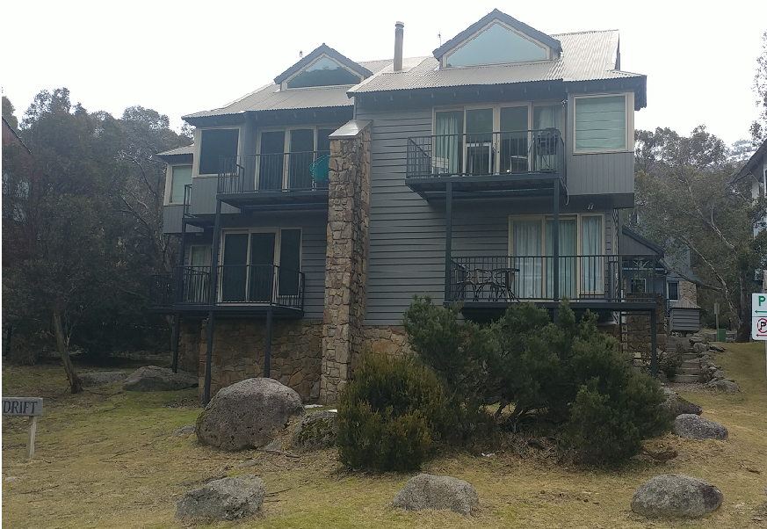

Lot 573, “Woodridge”
3 Riverside Terrace
Thredbo Village

Table of Contents
Introduction 3
Location 3
Site Suitability 3
Operational details 3
Snow Deposition 3
Social and Economic Impact 3
Access and Traffic 3
Privacy, Views and Overshadowing 3
Air and Noise 3
Soil, Water and Wastewater Management 3
Heritage 4
Aboriginal Cultural Heritage 4
Energy 4
Waste 4
Demolition 4
Notification & consent from other Snowdrift leases to extend front entry structure 8
External Colours 9
Use of non-slip tread mesh 9
Previous works completed – believed to be exempt 10
Main Apartment: 10
Flat: 11
Works to be completed under this DA 11
Apartment: 11
Flat: 11

Introduction

Proposed works are Repairs, Maintenance, Internal Refurbish, External Venting, and Accessibility.
A list of works is available on the last 2 pages of this document.

The works will have a positive environmental impact, noting the proposed addition of solar power and removal of the chimney, changing fireplace to gas, will have appositive environmental impact.

The purpose of this SEE is to describe the location and proposed works to the site, along with environmental effects they may bring.

Location

The site is located within Lot 573 Riverview Terrace, Thredbo.
Snowdrift apartment 1 is part of a complex of 3 apartments, located in the Woodridge area.

Site Suitability

The proposed alterations are suitable for the existing site.

Operational details

The building is to be available to family use or tourist accommodation, including for disabled guests through the addition of disabled features.

Snow Deposition

Social and Economic Impact

Access and Traffic

Privacy, Views and Overshadowing

Air and Noise

Soil, Water and Wastewater Management

There are no changes which will cause an impact. The number of beds remains unchanged.

Heritage

There are no heritage issues.

Aboriginal Cultural Heritage

There are no Aboriginal cultural heritage issues. All works are inside the building. Access to the building is via existing roads and paths.

Energy

There are overall reductions to the energy foot print resulting from the proposed changes. The fire place will change from wood to gas, and an electric hot water system will be replaced by instantaneous gas. The additional wall and ceiling lining will slightly increase the energy efficiency of the building.
The smaller downstairs flat allows for energy use to be minimised in the remainder of the dwelling when only one or two people are present.
Solar panels, battery and an EV charger will reduce the energy footprint overall.

Waste

There are no changes which will cause an impact to the waste from the property.
During construction, recyclable waste will be separated and recycled where possible.

Demolition

No external demolition is required. All building waste will be removed in builders bins and recycled where possible.

TABLE: State Environmental Planning Policy (Kosciuszko National Park—Alpine Resorts) 2007

Clause 2 Aim and objectives of Policy
(1) The aim of this Policy is to protect and enhance the natural environment of the alpine resorts, in the context of Kosciuszko National Park, by ensuring that development in those resorts is managed in a way that has regard to the principles of ecologically sustainable development (including the conservation and restoration of ecological processes, natural systems and biodiversity). | The proposed development dual-key conversion works are entirely internal to the dwelling, having no impact to the area external to the dwelling.  The additional wall and ceiling lining will slightly increase the energy efficiency of the building.  The smaller flat allows for energy use to be minimised in the remainder of the dwelling when only one person is present.
(2) The objectives of this Policy are as follows:  (a) to encourage the carrying out of a range of development in the alpine resorts (including the provision of services, facilities and infrastructure, and economic and recreational activities) that do not result in adverse environmental, social or economic impacts on the natural or cultural environment of land to which this Policy applies,  (b) to put in place planning controls that contribute to and facilitate the carrying out of ski resort development in Kosciuszko National Park that is ecologically sustainable in recognition of the fact that this development is of State and regional significance,  (c) to minimise the risk to the community of exposure to environmental hazards, particularly geotechnical hazards, bush fire and flooding, by generally requiring development consent on land to which this Policy applies. | This development creates additional accessible accommodation options.  There will be no adverse environmental or social or  economic impacts created by the proposed development.
Clause 14 Matters to be considered by consent authority
(1) In determining a development application that relates to land to which this Policy applies, the consent authority must take into consideration any of the following matters that are of relevance to the proposed development:
(a) the aim and objectives of this Policy, as set out in clause 2,
(b) the extent to which the development will achieve an appropriate balance between the conservation of the natural environment and any measures to mitigate environmental hazards (including geotechnical hazards, bush fires and flooding),
(c) having regard to the nature and scale of the development proposed, the impacts of the development (including the cumulative impacts of development) on the following:
- the capacity of existing transport to cater for peak days and the suitability of access to the alpine resorts to accommodate the development, | There is no change, number of guests remains the same
- the capacity of the reticulated effluent management system of the land to which this Policy applies to cater for peak loads generated by the development, | There is no change, number of guests remains the same
- the capacity of existing waste disposal facilities or transfer facilities to cater for peak loads generated by the development, | There is no change, number of guests remains the same
(iv) the capacity of any existing water supply to cater for peak loads generated by the development, | There is no change, number of guests remains the same
(d) any statement of environmental effects required to accompany the development application for the development, | There is no change.
(e) if the consent authority is of the opinion that the development would significantly alter the character of the alpine resort—an analysis of the existing character of the site and immediate surroundings to assist in understanding how the development will relate to the alpine resort, | There is no change, number of guests remains the same
(f) the Geotechnical Policy—Kosciuszko Alpine Resorts (2003, Department of Infrastructure, Planning and Natural Resources) and any measures proposed to address any geotechnical issues arising in relation to the development, | There is no change.  There are no geotechnical issues arising from the proposed works.
(g) if earthworks or excavation works are proposed—any sedimentation and erosion control measures proposed to mitigate any adverse impacts associated with those works, | There are no proposed earthworks or excavation.
(h) if stormwater drainage works are proposed—any measures proposed to mitigate any adverse impacts associated with those works, | There are no proposed stormwater drainage works.
(i) any visual impact of the proposed development, particularly when viewed from the Main Range, | The visual impact of the building will remain similar, with vents matching the building colour and an accessible ramp at the side door.  There are no changes to the outside of the dwelling.
(j) the extent to which the development may be connected with a significant increase in activities, outside of the ski season, in the alpine resort in which the development is proposed to be carried out, | N/A
(k) if the development involves the installation of ski lifting facilities and a development control plan does not apply to the alpine resort: | N/A
- the capacity of existing infrastructure facilities, and | N/A
- any adverse impact of the development on access to, from or in the alpine resort, | N/A
(2) The long term management goals for riparian land are as follows:
(a) to maximise the protection of terrestrial and aquatic habitats of native flora and native fauna and ensure the provision of linkages, where possible, between such habitats on that land, | No impact on terrestrial or aquatic environments
(b) to ensure that the integrity of areas of conservation value and terrestrial and aquatic habitats of native flora and native fauna is maintained, | No impact on terrestrial or aquatic environments
(c) to minimise soil erosion and enhance the stability of the banks of watercourses where the banks have been degraded, the watercourses have been channelised, pipes have been laid and the like has occurred. | No impact
15 Additional matters to be considered for buildings
(1) Building height
In determining a development application for the erection of a building on land, the consent authority must take into consideration the proposed height of the building (where relevant) and the extent to which that height:
(a) has an impact on the privacy of occupiers and users of other land, and | No change
(b) limits solar access to places in the public domain where members of the public gather or to adjoining or nearby land, and | No change
(c) has an impact on views from other land, and | There will be an accessible ramp from carpark to front door using similar material and colours
(d) if the building is proposed to be erected in Thredbo Alpine Resort—has a visual impact when viewed from the Alpine Way, and | No change- see answer to (1) (c) above
(e) if the building is proposed to be erected in Perisher Range Alpine Resort—needs to be limited so as to assist in maintaining the skyline when viewed from Kosciuszko Road and any other public roads, and | N/A
(f) if the building is proposed to be erected in an alpine resort other than Thredbo Alpine Resort or Perisher Range Alpine Resort—is similar to existing buildings in the resort where it is proposed to be erected, and | N/A
(g) if the building is proposed to be erected in Bullocks Flat Terminal—relates to the topography of its site. | N/A
(2) Building setback
In determining a development application for the erection of a building on land, the consent authority must take into consideration the proposed setback of the building (where relevant) and the extent to which that setback:
(a) assists in providing adequate open space to complement any commercial use in the alpine resort concerned, and
(b) assists in achieving high quality landscaping between the building and other buildings, and
(c) has an impact on amenity, particularly on view corridors at places in the public domain where members of the public gather, and
(d) is adequate for the purposes of fire safety, and
(e) will enable site access for pedestrians, services (including stormwater drainage and sewerage services) and the carrying out of building maintenance, and | No change
(f) will facilitate the management of accumulated snow. | No change
(3) Landscaped area
In determining a development application for the erection of a building on land, the consent authority must take into consideration (where relevant) the extent to which landscaping should be used:
(a) as a means of assisting in the protection of the unique alpine environment of the alpine resort concerned, and to maximise its natural visual amenity, for the benefit of visitors and natural ecosystems, and | No change
(b) to assist in the provision of adequate open space to complement any commercial use in the alpine resort concerned, and | No change
(c) to limit the apparent mass and bulk of the building, and | No change
(d) as an amenity protection buffer between the proposed building and other buildings, and | No change
(e) as a means of reducing run-off, and | No change
(f) to protect significant replaceexisting site features and limit the area of any site disturbed during and after the carrying out of development. | No change

Notification & consent from other Snowdrift leases to extend front entry structure

Neighbours in Appt 2 & 3 are aware of the planned works, as is our neighbour in Talgarra, any questions will continue to be addressed. been answered to date.

Consent from the neighbours are in the emails below:
Appt 2:
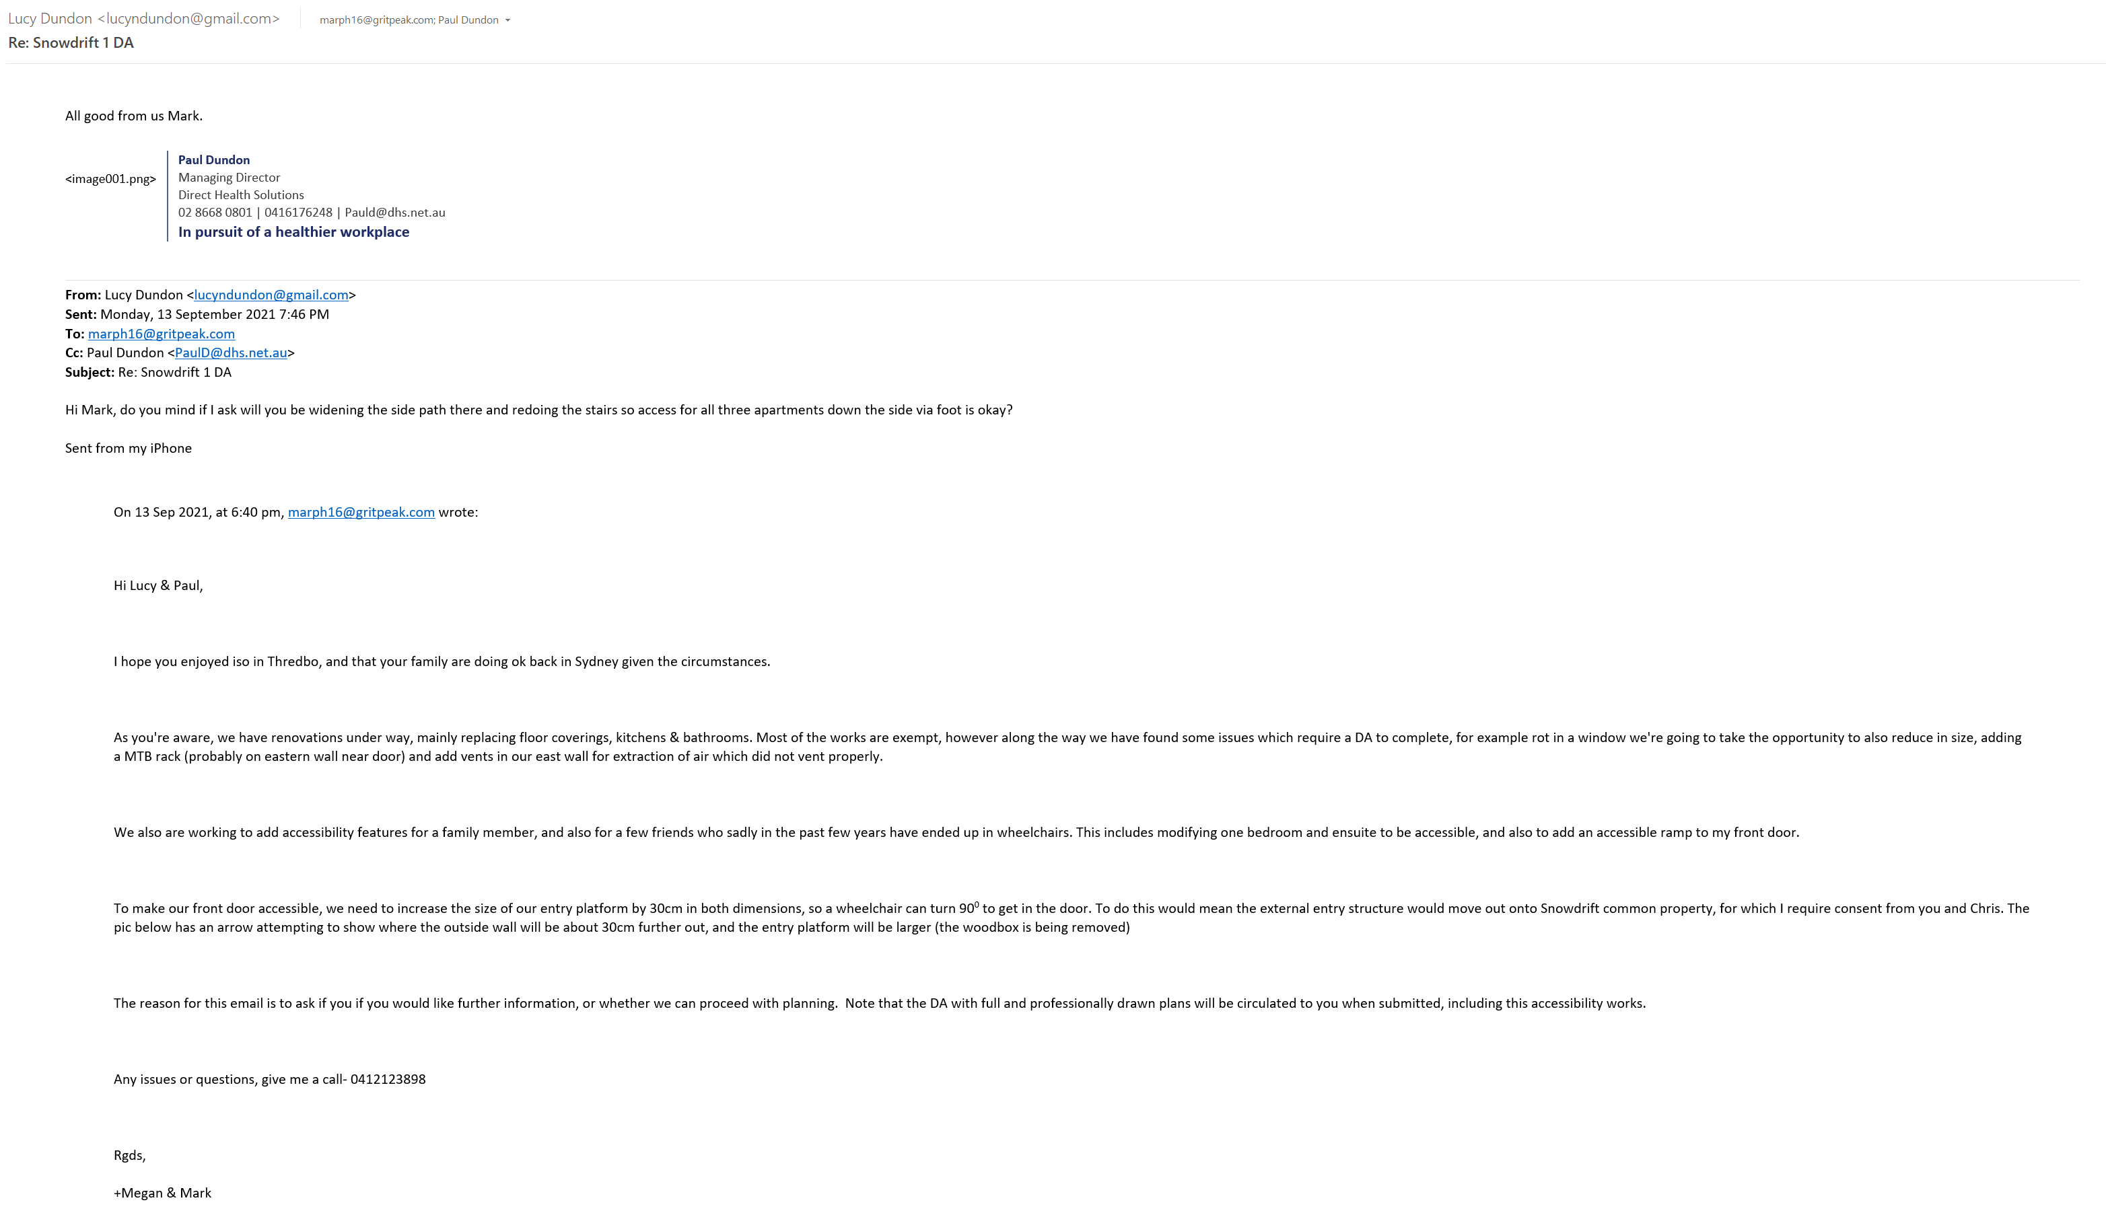
Appt 3:
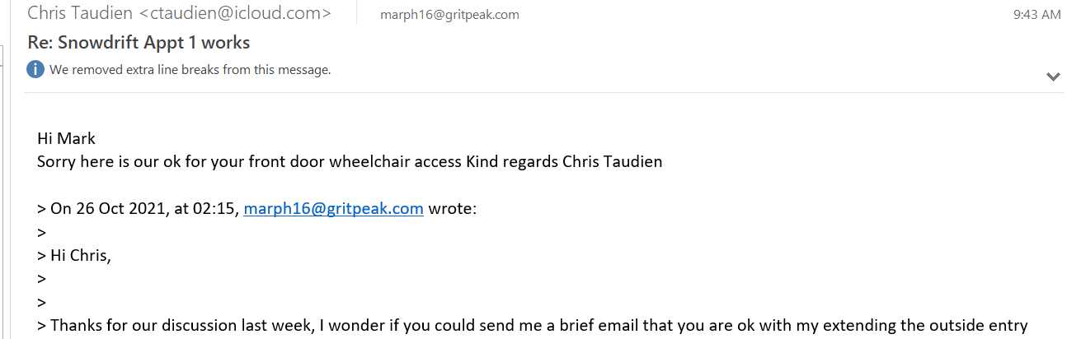

External Colours

Same as existing colours will be used.

Steelwork- Dulux “Domino”
Remainder (weatherboard): Dulux “Organic”

Geotech statement via email:
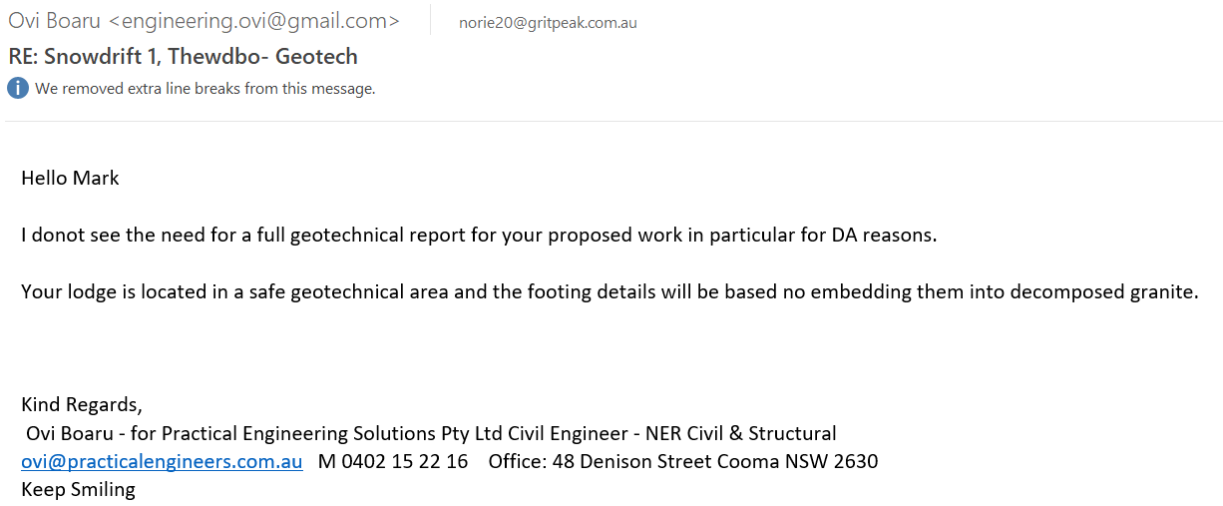

Summary of works

Solar generation:

We are proposing a solar panel installation. We are advised by our local installer that the system would not need a DA however this is something we wanted to mention. If installed, cabling will use an existing external air conditioning duct on the NE wall. The plans do include a small structure under the front balcony as provision for a battery storage system, which is part of this DA.

Works to be completed under this DA

- Blue items have been completed with the understanding they are exempt works.
- Purple items have not been completed as a DA is required.

Main Apartment:
- Upgrade kitchen, laundry & bathrooms
- Move 2nd floor bedroom & ensuite doors for privacy (guests in bedroom needed to walk in view of people in kitchen/lounge/dining to get to/from ensuite & shower
- Create cavity for kitchen fridge to extend further back so kitchen would be more functional
- Upgrade 2nd floor wardrobe
- Remove 3rd level nib walls (previously had doors between removed per purchase inspection, removed the rest of the nib to create open space).
- Upgrade water heater in loft void
- Make 1st floor bedroom & bathroom accessible
- Make entry accessible by installing walkway to AS1428.1 on NE side from carpark to entry with eave
- Add storage for solar batteries
- Add charging for powered wheelchairs, e-bikes & electric vehicles
- Upgrade wood fireplace with gas fireplace
- Upgrade lvl3 bathroom skylight with larger fixed skylight
- Upgrade lvl3 main opening skylight (Leaking, same size not available so using similar size and BCA compliant model)
- Install additional satellite dish for satellite internet (additional to existing satellite TV dish and free to air TV antenna)

Flat:
- (All fire separation remains intact, no penetrations etc- same builder used)
- Remove nib walls & concertina doors separating bed from lounge, and remove trapdoor completely (previously bolted closed per purchase inspection)
- Move wardrobe to other side of room for better storage
- Upgrade kitchen & bathroom
- Move laundry into bathroom & remove laundry cupboard under stairs to open space
- Gravel trench in front of building to move moisture away from building to manage mould
- Remove outside wood box & create accessible ramp to front door
- Add 3 air extraction vents (level 3 bathroom, level 2 bathroom, level 2 kitchen range hood (all used to vent to voids in building)
- Add gas hot water flue penetration
- Add external MTB storage cage or rack
- Replace exterior sliding doors like for like, level 1 & 2 balcony (water ingress)
- Upgrade wood fire with gas fireplace & surround
- Add accessible stair climber for stairs level 1 to level 2
- Replace rotten window with smaller window matching other existing window size

